












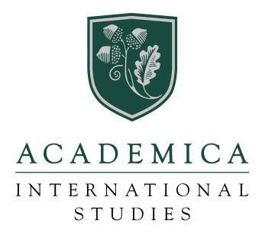




HONOR ROLL CERTIFICATE
IN RECOGNITION FOR OUTSTANDING PERFORMANCE IN THE AIS DUAL DIPLOMA PROGRAM

HAS BEEN PLACED ON THE HONOR ROLL
For the 2024-2025 Academic School Year

Principal, Academica International Studies

